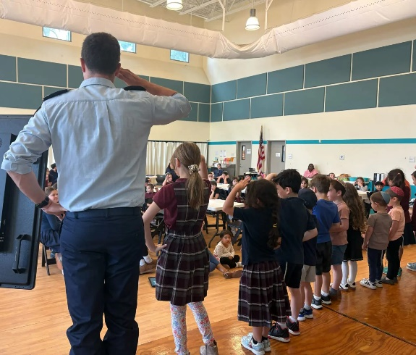

THE CHALLENGE!
You are 3 months in your shlichut and the first thing you heard is complaints about last year’s Yom Haatzmaut program. Even during your Hafifa, the former Shlicha, Chava Halazman, told you: “look, this was my biggest challenge and I was not happy with the results.”
The Shlicha got a $10,000 budget and the room was a third empty (200 people came instead of the usual 600). Some people said it’s because of the war and people are fatigued, some people blamed the weather (yes, it’s true, there was a bit of rain at the end) or the competing big baseball game with the Tomorrow Land Wolves, the bottom line is nobody was happy with the end result.
Chava hired a Hava Nagila band that cost $4,000, spent $2,000 of Bamba bags, rented the space for $2000 and paid other vendors. Now your office is still full of Bamba, so much that every visitor must leave with one bag!
Your local Natzig, Lee Yeshzman, came to visit you and support you on your first month. Lee mentioned that there is a new initiative with WZO called Shlichim Bemadim, where you can bring 2 wounded of IDF soldiers in the community for $2,000, all included.
You got excited and started to build an itinerary. You could spend a week during visits to schools, synagogues, JCCs. You even thought you could bring soldiers from your partnership region. You could impact more than 600 people in just a few days…
You went to your supervisor Ayelet who is very supportive and presented the idea to the Chief Impact Officer Scott. Scott was interested and asked for more data and KPIs. He asked for metrics and to measure the ROI
He suggested you bring it up to the Chair who suggested to present it to the committee.

