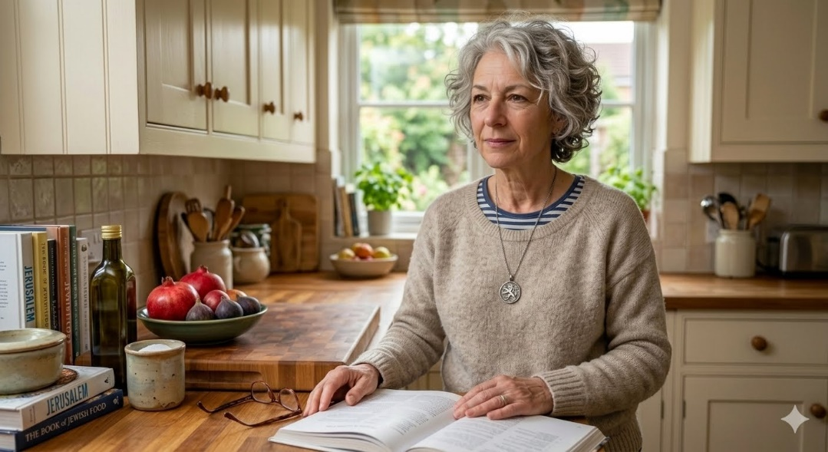

Shari Baumgarten, 64
Shari was born in Chicago and moved to Tomorrow Land after she married her husband, Charles, originally from Tomorrowland who is a radiologist. Shari is a librarian but took time off to raise her children and volunteer in the Jewish community.
Shari has been involved at the Federation for over 40 years. She is the past Chair of Women’s Philanthropy, she was on Cabinet. She also Chaired PJ Library, the Jewish Educational Alliance and is very involved in the “Shalom new families” program.
When you arrived, she came over to your home with fresh baked cookies. She invited you in the first Shabbat. She says Shlichim are “the Israeli sunshine in the community.” Her daughter is hosting a shinshin this year and she is so excited her grandson is speaking Hebrew at home.
Shari attends every Israel engagement committee and her voice is very respected and measured. People listen to her when she speaks.
NOT TO READ
Last year Shari attended the Yom Haatzmaut party. As much as she is attached to it, she thinks some “tweaks and changes are needed.” Shari trusts the Jewish professionals and usually goes with the flow, she does not like to create too much conflict but understands need for change.

