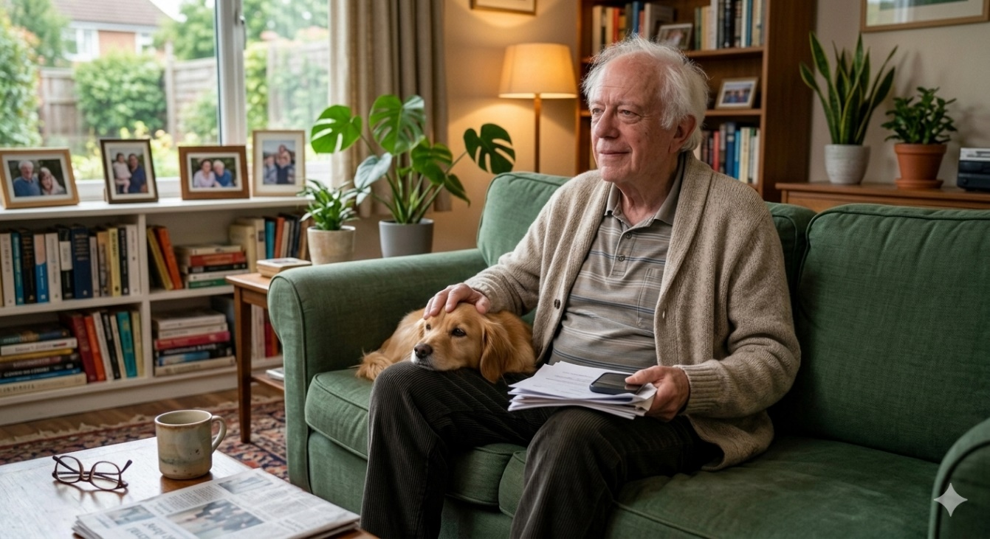

Mort Davidson, 72
Mort was born and raised in Tomorrow Land. He is a 3rd generation Tomorrowlander, his grandparents came from Poland to escape the pogroms.
Mort is a retired accountant: he owned his own firm and his son runs it even if he still involved. Until last year he was Chair of JCRC, he was once the campaign Chair, he led many missions to Israel and gives generously to FIDF and Magen David where he sits on the local Board. Mort always comes to the Israel engagement committee, he says it’s the most important committee at Federation.
Mort loves the Yom Haatzmaut program. Every year he looks forward to it. He puts on his favorite Israel tee shirt and is awake at 5 am to set up everything. He makes sures his granddaughters come and together they set up a balloon station.
DO NOT READ TO THE GROUP:
Change is difficult and you are holding dear to the program that you feel emotionally attached to. “It’s not about the numbers, it’s about the emotions we give our children”

