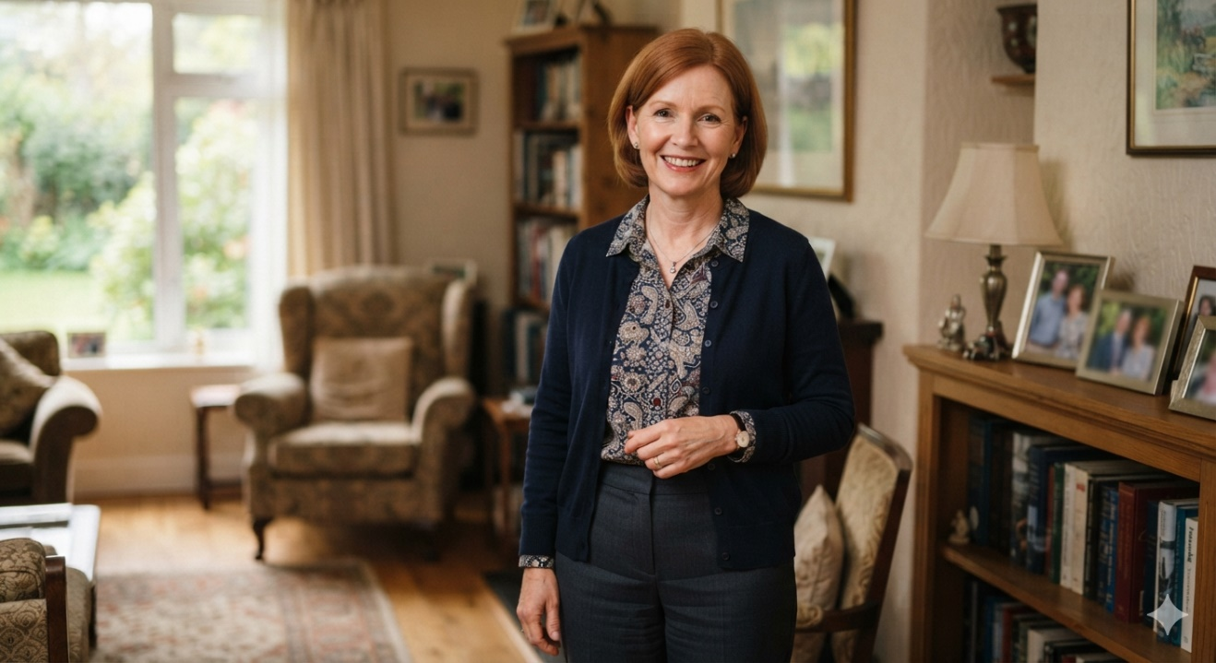

Betsy Glickman
Betsy is second generation from Tomorrow Land community. Her father was a successful owner of a steel company and was once the Chair of the Federation. Betsy is married to David with 2 adult children, she works as an HR attorney and is married to a cardiac surgeon.
Betsy went to Israel five times in her life. Her daughter just came from Birthright. David is very active in AIPAC. She went on a Momentum community trip last year. Together, they make a large gift and are part of the King David Society. Betsy recently endowed her Lion.
Last year, after Chairing the Women’s Philanthropy campaign, Betsy was asked to Chair the Israel engagement committee. Betsy accepted even though she has not too involved on the planning side of Federation and more on the campaign side. Last year, she helped a little bit with the big Yom Haatzmaut campaign by hosting a booth.
DO NOT READ TO THE GROUP.
Betsy is still saying she is “new to this” and relies a lot on the professional and his opinion. Betsy is a good listener but is worried about taking big risks. She likes things to go through a consensus as an attorney and likes process and time tables.

