ArtReach Mishkan
Bridging Worlds Through Israeli Art

A Virtual Journey from the Mishkan Museum of Art, Ein Harod

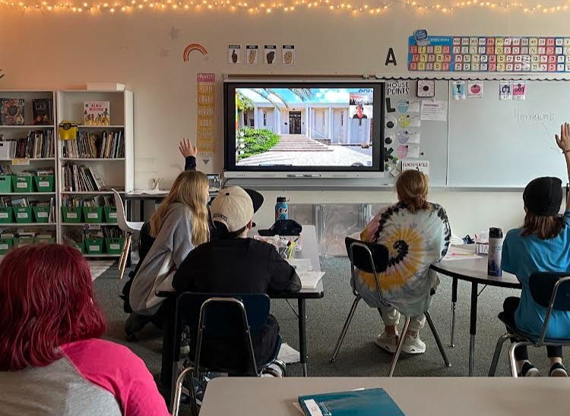

What is ArtReach Mishkan?

ArtReach Mishkan is a unique educational program developed by Mishkan Museum educators, offering children worldwide a personalized, creative connection to Israel through art. Students will discover the story of Israel's first art museum, explore Jewish heritage from diverse communities, and engage with contemporary questions facing Israeli society.

What will you experience with ArtReach?

Interactive Learning Experience:
⏺ Comprehensive pre-program materials for class preparation
⏺ Two 50-minute live virtual tours with expert museum guides including games, drama, debate and more
⏺ Customizable content exploring Jewish holidays, Kibbutz life, Israeli society, Hebrew art vocabulary and artistic innovation
⏺ Small group format (up to 20 students, Grades 3-8) for optimal engagement

Creative Expression:
⏺ Detailed instructions for creative art workshop between sessions
⏺ Student artwork featured in our digital international gallery and opportunity to share with your local community
⏺ A personalized, creative connection to Israel for every child

  Contact
  Us
  Register
  Now

Click to watch >>

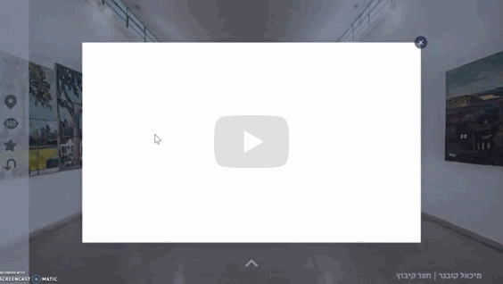

Art as a Bridge
Why Now?

In this crucial moment, as communities seek meaningful ways to connect with Israel, art speaks a universal language that resonates with every child. The Mishkan Museum offers a unique pathway to Israel that weaves together past, present, and future through the transformative power of artistic expression.
This meaningful engagement fosters connections that transcend distance and difference, bringing strength and hope to our communities.

Since 2021, ArtReach Mishkan (formerly ZoomArt) has successfully connected children across the United States—including communities in Omaha, St. Louis, and Denver—with Israel's diverse cultural landscape and history.
Participants build lasting connections, strengthening the link between Israel and world Jewry in a way that is uniquely possible through the language of art.

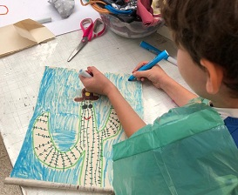 | 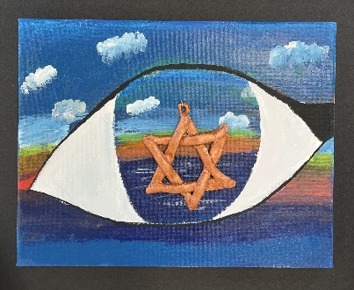 | 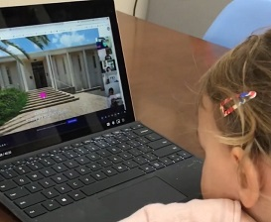

“Loved it!
My students gained a new knowledge of Israeli/Jewish art!
A meaningful way for kids to connect with their heritage,
a wonderful way to express experiences in a way that they can connect with.”

- Rachel, 5th grade teacher, St. Louis

  Contact Us
  Register Now

The Mishkan Legacy

The Mishkan Museum of Art, founded in 1937 in the heart of Kibbutz Ein Harod in northern Israel, is rooted in the belief that art, culture, knowledge and understanding are essential to life. The first art museum built in Israel, it is a breathtaking architectural gem and leading cultural center for local, national, and international artists. Its collection of over 20,000 works of art and Judaica reflects the multilayered face of Israeli society, from historical treasures to contemporary expressions >> Mishkan Museum website

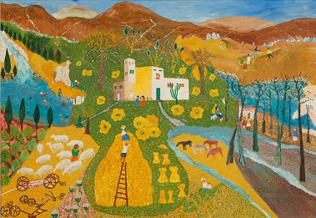 | 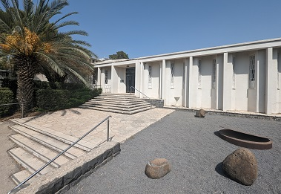

Shabbat at the Foot of Mount Gilbo'a, Yehoshua Brandstatter, 1963-66

